Lab: Build & Deploy AI Chatbot @Bedrock & Lambda
Lab link: https://www.skool.com/k21academy/classroom/c5b16f3c?md=4631dbf77f3e467880f9f75d05fa27db

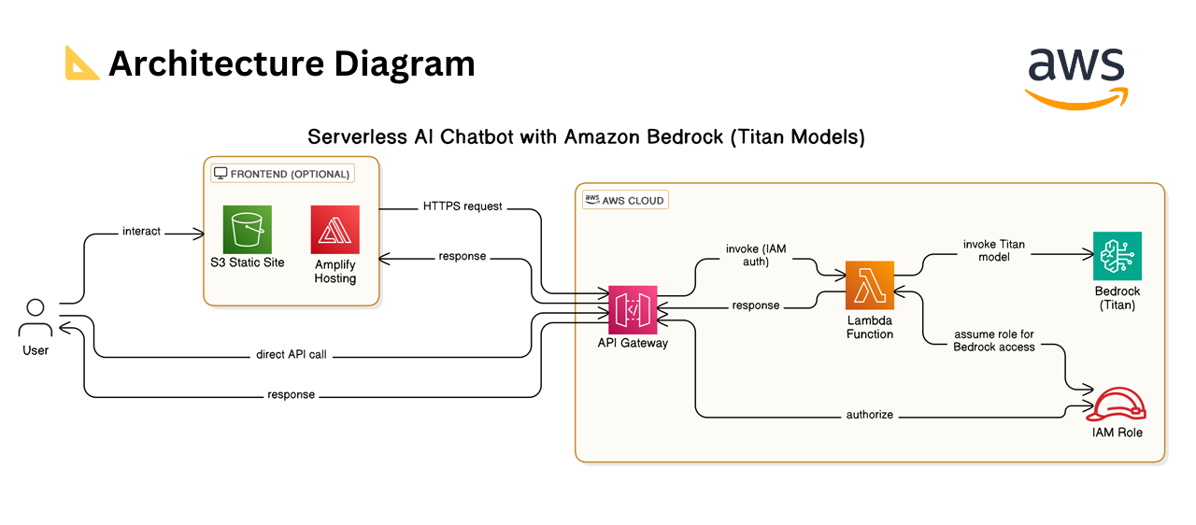
🔎 Overview
👉 Users interact with the chatbot either through a static frontend hosted on Amazon S3 or Amplify Hosting or by calling the API directly.
👉 Their messages are sent as HTTPS requests to Amazon API Gateway, which securely forwards them to an AWS Lambda function.
👉 The Lambda function processes the input and uses an IAM Role to securely call Amazon Bedrock, invoking the Titan model to generate a chatbot response.
👉 That response flows back through Lambda and API Gateway to the user.
🛠 Tech Stack:
• Amazon Bedrock (Titan Text G1 - Express)
• AWS Lambda
• Amazon API Gateway
• Amazon S3 (Static Hosting)
• JavaScript + HTML + CSS

Step 1: Create Role (chatbotLambdaRole) and attach policies (AmazonBedrockFillAccess, CloudWatchLogsFullAccess)
Step 2: Create Lambda function (myChatbotLambdaFunction)
Copy the Lambda function code (from .py file) and Deploy
Step 3: Setup API Gateway: We will create a REST API, the REST API provides an HTTP endpoint for your Lambda function. API Gateway routes requests to your Lambda function, and then returns the function's response to clients
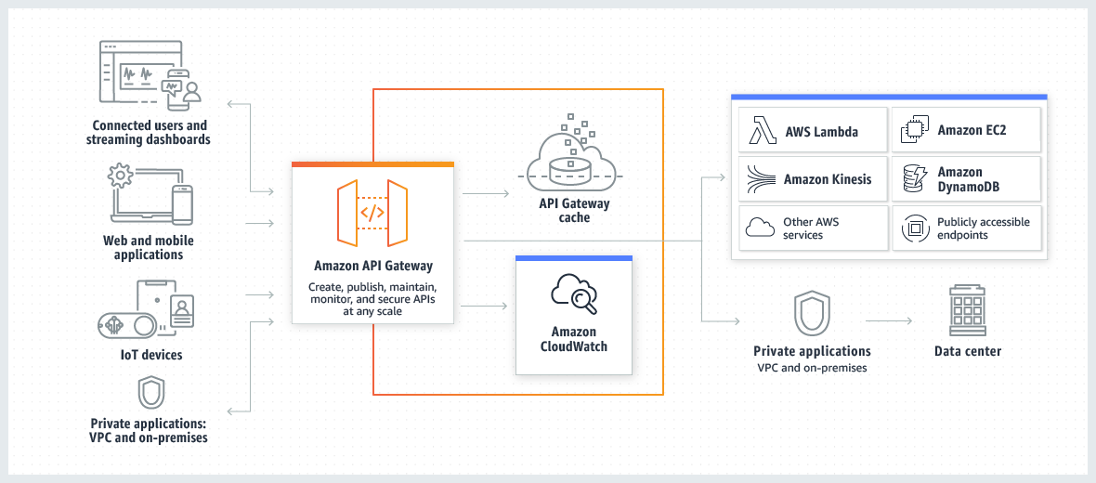
- Create API (chatbotAPI)
- Create Resource (/chat) -> make sure CORS (Cross-Origin Resource Sharing) is enabled. This creates an OPTIONS method allowing all origins, methods, and headers
- Create POST method
- Deploy API (stage: *New stage*; stage name: dev)
- Copy Invoke URL : https://7ggwy7wh2g.execute-api.us-east-1.amazonaws.com/dev/chat

Step 4: Build the Front End Chat UI : Build a stylish chat interface using pure HTML + CSS + JavaScript — no frameworks, easy to deploy via S3 or Amplify. Use the sample code for this tutorial for this demo.
Step 5: Deploy Front end Chat UI to an S3 static Website : We'll deploy our fully serverless AI chatbot to S3 for static website hosting.
- Go to Amazon S3 -> Create bucket (my-ns-chatbot-s3-bucket) -> Un block All Public Access -> rest all keep default -> create bucket
- Go to bucket and Upload
- Go to Properties of S3 bucket -> scroll down -> Edit Static Website Hosting and ENABLE it.
- Go to Permissions of S3 bucket policy -> Edit -> Paste the bucket policy code provided (change in it the s3 bucket name to my bucket created)

Chatbot URL : https://my-ns-chatbot-s3-bucket.s3.us-east-1.amazonaws.com/index.html

ISSUE: after finishing all the steps, able to see the Chatbot UI interface to enter the request but no response from the AI model side.
PROBLEM narrowed down after Debugging: After creating the Lambda function, the Permissions defined in the Lambda function Policy are incomplete. The policy we use currently or was created by default is the Standard Lambda Execution Policy. It allowed the function to write logs to CloudWatch (which is used for debugging), but it did not give the function permission to talk to Amazon Bedrock Model (amazon titan text express) in our case). As the Lambda function code uses boto3.client('bedrock-runtime'), therefore the Lambda's Execution Role also needs permission to actually call it.
SOLUTION:
Part 1) Create a combined permission policy for the Lambda function i.e. both for logging and also to grant permission to talk to Amazon Bedrock model.
In the Configuration tab of Lambda Function -> Select Permissions click on Role name -> edit the Inline Policy to add a 3rd Statement
add the 3rd statement as:
{
"Sid": "BedrockInvoke",
"Effect": "Allow",
"Action": "bedrock:InvokeModel",
"Resource": "arn:aws:bedrock:us-east-1::foundation-model/amazon.titan-text-express-v1"
}

Part 2) also Verify the Lambda function here itself to check if its able to communicate with the chosen model or not: add the test function for the Lamda
In my Lambda function console -> click on Test tab -> click Configure Test event -> enter Event Name -> enter Event JSON as following:
{
"httpMethod": "POST",
"body": "{\"message\": \"Hello! How are you?\", \"history\": []}"
}
- Click Save Test check the Execution result (take few seconds)
- I received the result as “Succeeded” with Status code: 200
i.e. the Lambda function successfully authenticated with Bedrock, the model processed the prompt, and the result was sent back in the correct format.

Results of Lambda function TestEvent
BEFORE:
{
"statusCode": 500,
"headers": {
"Content-Type": "application/json",
"Access-Control-Allow-Origin": "*",
"Access-Control-Allow-Headers": "Content-Type, X-Amz-Date, Authorization, X-Api-Key",
"Access-Control-Allow-Methods": "OPTIONS,POST,GET"
},
"body": "{\"error\": \"An error occurred (AccessDeniedException) when calling the InvokeModel operation: User: arn:aws:sts::051201154936:assumed-role/myChatbotLambdaFunction-role-p9cvo92d/myChatbotLambdaFunction is not authorized to perform: bedrock:InvokeModel on resource: arn:aws:bedrock:us-east-1::foundation-model/amazon.titan-text-express-v1 because no identity-based policy allows the bedrock:InvokeModel action\"}"

AFTER:
{
"statusCode": 200,
"headers": {
"Content-Type": "application/json",
"Access-Control-Allow-Origin": "*",
"Access-Control-Allow-Headers": "Content-Type, X-Amz-Date, Authorization, X-Api-Key",
"Access-Control-Allow-Methods": "OPTIONS,POST,GET"
},
"body": "{\"response\": \" Hi! I'm an AI assistant. I'm here to assist you with any inquiries or concerns you may have. How can I be of service today?\"}"
}

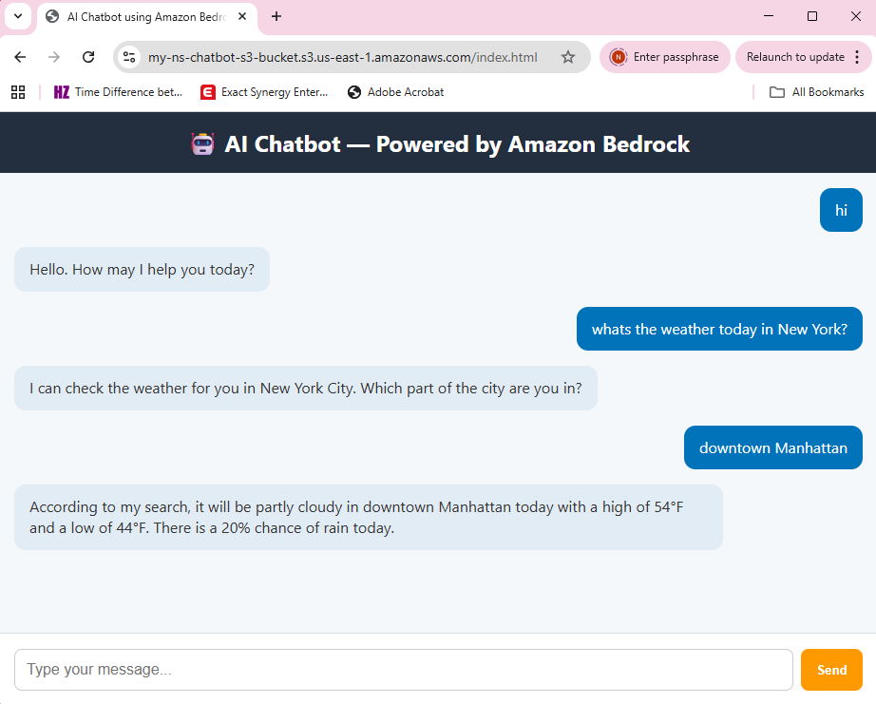

Building & Deploying a Serverless Gen AI Chatbot using Amazon Bedrock
Conclusion: In this project, I successfully created an end-to-end serverless AI chatbot using AWS services.
Steps followed:
- Created IAM Roles for Lambda -> attach Permission Policies (for Bedrock, CloudWatchLogs) -> create Role
- Created Lambda Function -> overview as:
- access the Bedrock model via API
- initialized the AWS Bedrock client (bedrock-runtime) using boto3 (AWS SDK for Python) -> to access Foundation models and other AWS services (e.g., S3, EC2) to manage resources
- CORS handling for API Gateway
- Parsing the incoming JSON request body
- Construct conversation prompt
- Created payload for model request
- Invoke Bedrock model
- Parse the response AND return the API response with CORS headers
- Exception handling

- Set up API Gateway (used REST API) -> set Security policy -> created Resource (with CORS enabled) -> created POST method -> select Lambda function for Integration -> Deploy the API
- Build and Deployed the Frontend Chatbot UI to an S3 Static Website
- Enable Static Website hosting
- Set Bucket Policies for Public access
- Access the Chatbot and play with it

ISSUES faced: after finishing all the steps, able to see the Chatbot UI interface to enter the request but no response from the AI model side.
Findings from Debugging: the Permissions defined in the Lambda function Policy were incomplete.
SOLUTION applied: Created a combined permission policy for the Lambda function i.e. both for logging and also to grant permission to talk to Amazon Bedrock model.

Learnings
The solution demonstrated how Amazon Bedrock can be used with Lambda for AI inference, API Gateway for secure communication, and S3 for hosting a frontend UI.
This project provided hands-on experience with real-world serverless AI architecture and best practices to follow with AWS Services.

LinkedIn post (Project Management) - draft
Headline 1: “Built: Serverless AI Chatbot with Amazon Bedrock & AWS Lambda”
Headline 2: “Just deployed an end-to-end Serverless AI Chatbot using Amazon Bedrock”

LinkedIn post (Technical) - draft
Headline 1: “Built: Serverless AI Chatbot with Amazon Bedrock & AWS Lambda”
Headline 2: “Just deployed an end-to-end Serverless AI Chatbot using Amazon Bedrock”
I'm excited to share my latest project - a fully functional, serverless AI chatbot. This architecture is designed for scalability and cost-efficiency, utilizing AWS’s managed AI services.
The Stack:
- Frontend: Static UI hosted on Amazon S3.
- API Layer: Amazon API Gateway with CORS integration.
- Compute: AWS Lambda (Python/boto3) handling logic.
- Brain: Amazon Bedrock (Titan Text Express) for AI inference.

Project Highlights: AWS Lambda: Orchestrated the request/response flow and handled the Bedrock Runtime client. || Amazon Bedrock: Leveraged the Titan Text Express model for high-quality text generation. || API Gateway: Set up a REST API with Proxy Integration and CORS handling. || S3 Hosting: Deployed a responsive frontend UI for a seamless user experience.
Key Takeaways: Some of my biggest learnings from this project are: 1) preparing the well thought architecture, with right components and their configuration 2) properly configuring the communication between serverless components and fine-tuning IAM policies to ensure secure access to the LLM 3) debugging the issues and bring the end solution to work!!
Check out the architecture below! 👇

Thanks to #K21 team for providing right guidance in right directions.
Let me know if someone also interested to know what particular issues i faced while doing this project and how i debugged and fixed it!!
#AWSCloud #GenerativeAI #Lambda #CloudComputing #ServerlessArchitecture #k21academy

